**INSTITUTE OF ENGINEERING**

ADVANCED COLLEGE OF ENGINEERING AND MANAGEMENT

Kupondole, Lalitpur

**(AFFILIATED TO TRIBHUVAN UNIVERSITY)**



Lab no:3

Subject: Computer Network

**Submitted By: Submitted To:**

Department of Computer

and

Electronics Engineering

Name: Sameep Dhakal

Roll no: ACE074BCT063

Date: 09/07/2021

**Lab 3: OSPF routing and VLAN on ipv4.**

# **Objective:**

1. Set up OSPF routing protocol
2. Visualize VLAN setup

# **Introduction**

Open Shortest Path First (OSPF) is a routing protocol for Internet Protocol (IP) networks. It uses a link state routing (LSR) algorithm and falls into the group of interior gateway protocols (IGPs), operating within a single autonomous system (AS). It is defined as OSPF Version 2 in RFC 2328 (1998) for IPv4. The updates for IPv6 are specified as OSPF Version 3 in RFC 5340 (2008). OSPF supports the Classless Inter-Domain Routing (CIDR) addressing model. OSPF is a widely used IGP in large enterprise networks.

A VLAN (virtual LAN) is a subnetwork which can group together collections of devices on separate physical local area networks (LANs). A LAN is a group of computers and devices that share a communications line or wireless link to a server within the same geographical area.

VLANs make it easy for network administrators to partition a single switched network to match the functional and security requirements of their systems without having to run new cables or make major changes in their current network infrastructure. VLANs are often set up by larger businesses to re-partition devices for better traffic management.

VLANs are also important because they can help improve the overall performance of a network by grouping together devices that communicate most frequently. VLANs also provide security on larger networks by allowing a higher degree of control over which devices have access to each other. VLANs tend to be flexible because they are based on logical connections, rather than physical.

## **OSPF**

Design:

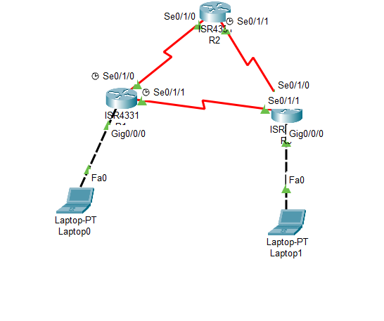

**Procedure:**

1. First the required tools were selected.
2. The required ports of the routers were turned on.
3. Then the IP and subnet mask for each Laptop and router ports was set
   1. For laptops this was gone by going to the desktop and ip configurations
   2. For routers this was done by going to the configuration and selecting the required port
4. Required connections were made between the routers and laptops
5. The OSPF network was added in the required routers through the routing section of the config tab .  
     
     
   codes:

**Router1**

Router>enable

Router# config terminal

Router(config)#interface FastEthernet0/0

Router(config-if)#ip address 192.168.1.1 255.255.255.0

Router(config-if)#no shutdown

Router(config-if)#exit

Router(config)#interface Serial2/0

Router(config-if)#ip address 10.0.0.1 255.0.0.0

Router(config-if)#clock rate 64000

Router(config-if)#no shutdown

Router(config-if)#exit

Router(config)#interface Serial3/0

Router(config-if)#ip address 40.0.0.1 255.0.0.0

Router(config-if)#clock rate 64000

Router(config-if)#no shutdown

Router(config-if)#exit

Router(config)#router ospf 1

Router(config-router)#router-id 1.1.1.1

Router(config-router)#network 10.0.0.0 0.255.255.255 area 0 //*wild card mask

Router(config-router)#network 40.0.0.0 0.255.255.255 area 0//*wild card mask

Router(config-router)#network 192.168.1.0 0.0.0.255 area 0

Router(config-router)#end

Router#wr

Router#

**Router2**

Router>enable

Router# configure terminal

Router(config)#interface Serial2/0

Router(config-if)#ip address 10.0.0.2 255.0.0.0

Router(config-if)#no shutdown

Router(config-if)#exit

Router(config)#interface Serial3/0

Router(config-if)#ip address 30.0.0.1 255.0.0.0

Router(config-if)#clock rate 64000

Router(config-if)#no shutdown

Router(config-if)#exit

Router(config)#router ospf 1

Router(config-router)#router-id 2.2.2.2

Router(config-router)#network 10.0.0.0 0.255.255.255 area 0//*wild card mask

Router(config-router)#network 30.0.0.0 0.255.255.255 area 0//*wild card mask

Router(config-router)#end

Router#wr

Router#

**Router3**

Router>enable

Router# configure terminal

Router(config)#interface Serial2/0

Router(config-if)#ip address 30.0.0.2 255.0.0.0

Router(config-if)#no shutdown

Router(config-if)#exit

Router(config)#interface Serial3/0

Router(config-if)#ip address 40.0.0.2 255.0.0.0

Router(config-if)#no shutdown

Router(config-if)#exit

Router(config)#interface FastEthernet0/0

Router(config-if)#ip address 192.168.100.1 255.255.255.0

Router(config-if)#no shutdown

Router(config-if)#exit

Router(config)#router ospf 1

Router(config-router)#router-id 3.3.3.3

Router(config-router)#network 30.0.0.0 0.255.255.255 area 0//*wild card mask

Router(config-router)#network 40.0.0.0 0.255.255.255 area 0//*wild card mask

Router(config-router)#network 192.168.100.0 0.0.0.255 area 0

Router(config-router)#end

Router#wr

Router#

Checking OSPF status from any Router

Router#show ip ospf neighbor

Router#show ip ospf database

Router#show ip route ospf

Output:

Ping laptop 1 to 2

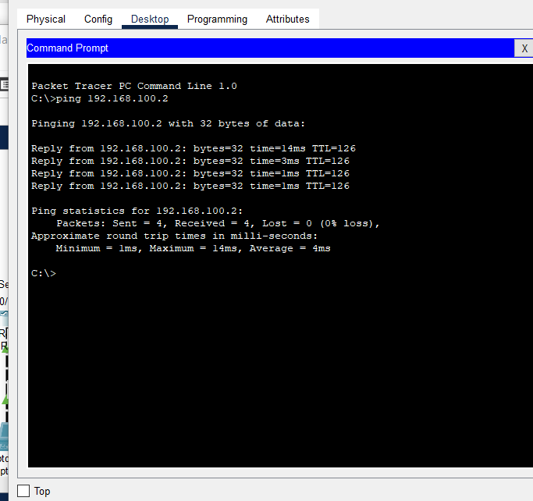

ping laptop 2 to 1

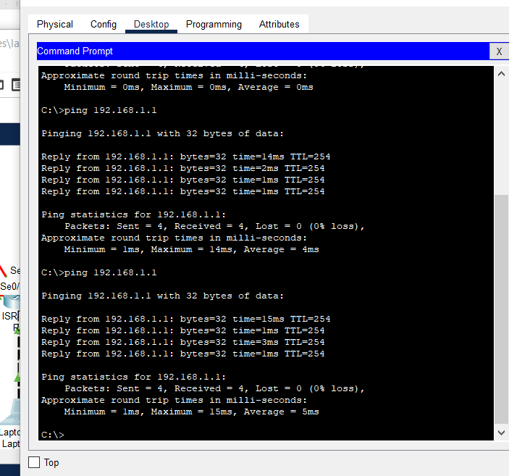

Ospf show ip 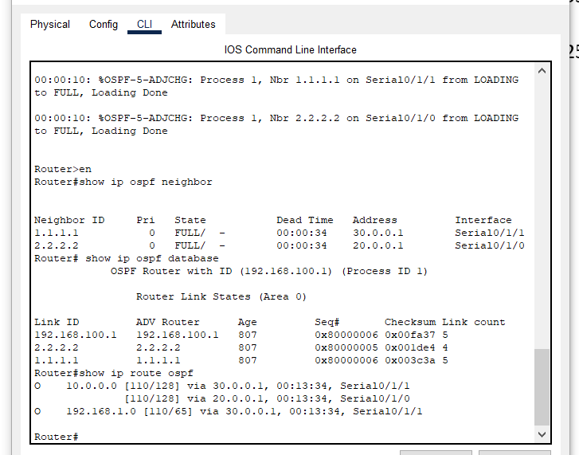

**VLAN**

Design:

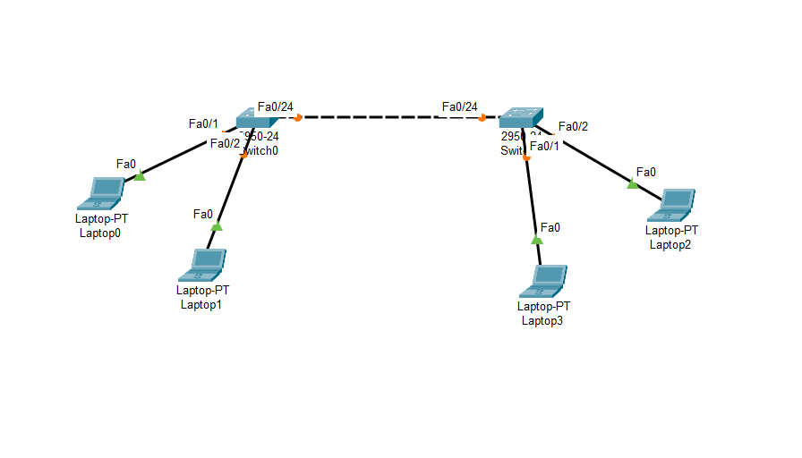

Procedure:

1. First the required tools were selected.
2. The required ports of the switches were turned on.
3. Then the IP and subnet mask for each Laptop ports was set
   1. For laptops this was gone by going to the desktop and ip configurations
   2. For switches this was done by going to the configuration and selecting the required port
4. Required connections were made between the switches and laptops

The VLAN was configured .

Codes:

Switch>enable

Switch # configure terminal

Switch(config)#vlan 10                 //vlan database configuration start from here with number

Switch(config-vlan)#name Account //name assigning on vlan number

Switch(config-vlan)#vlan 20

Switch(config-vlan)#name Exam

Switch(config-vlan)#exit // vlan end

Switch(config)#interface  fa0/24

Switch(config-if)#switchport mode trunk // two-way communication on multiple networks

Switch(config-if)#exit

Switch(config)#interface fa0/1

Switch(config-if)#switchport access vlan 10   // assigning vlan for switch to virtually divide

Switch(config-if)#exit

Switch(config)#interface fa0/11

Switch(config-if)#switchport access vlan 20

Switch(config-if)#exit

Switch(config)#interface range fa0/15-18  // assigning multiple ports into single vlan

Switch(config-if-range)#switchport  access vlan 20

Switch(config-if-range)#exit

Switch(config)#exit

Switch#wr

Output:

From laptop 1

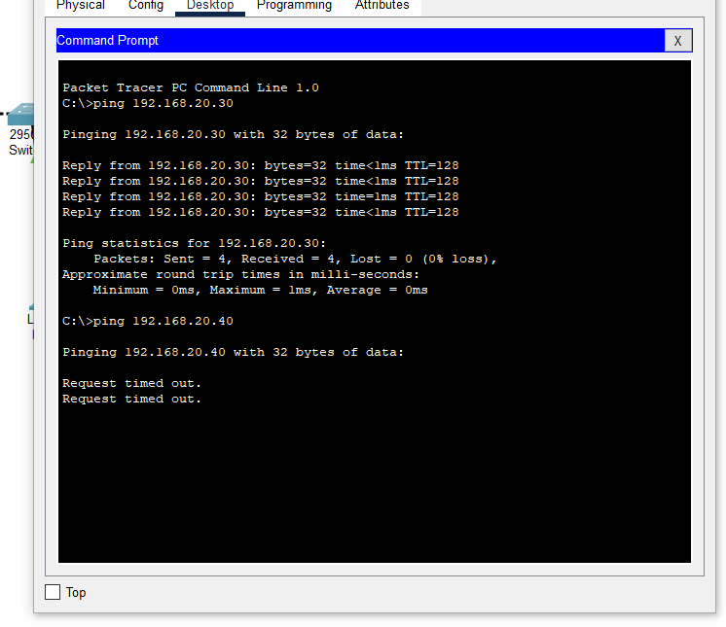

Laptop 2

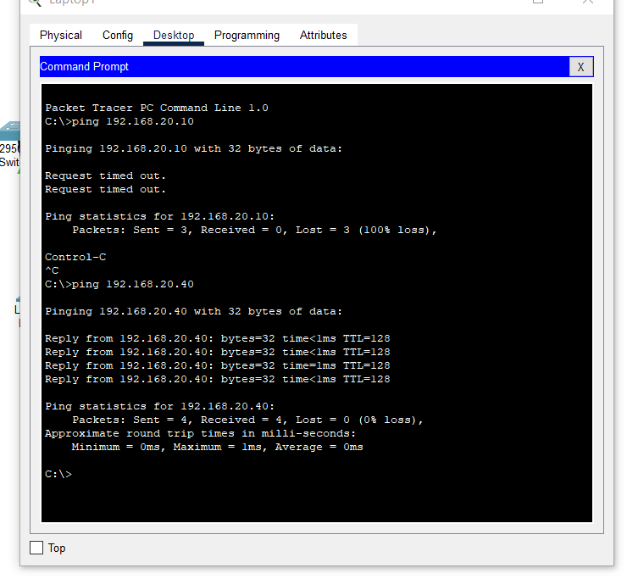

Laptop 3

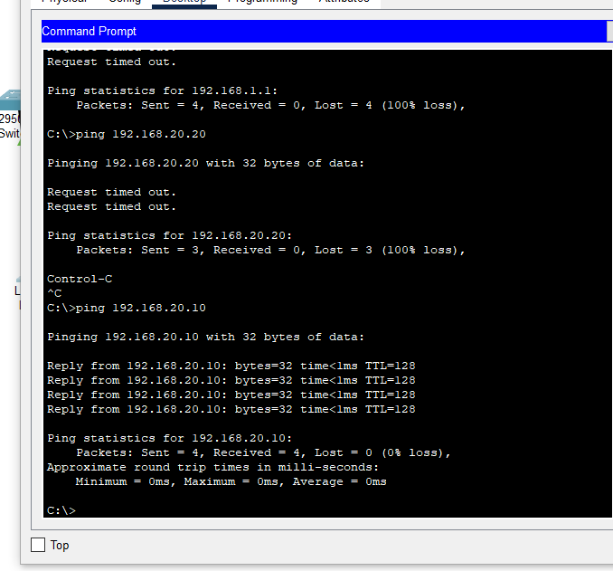

Laptop 4

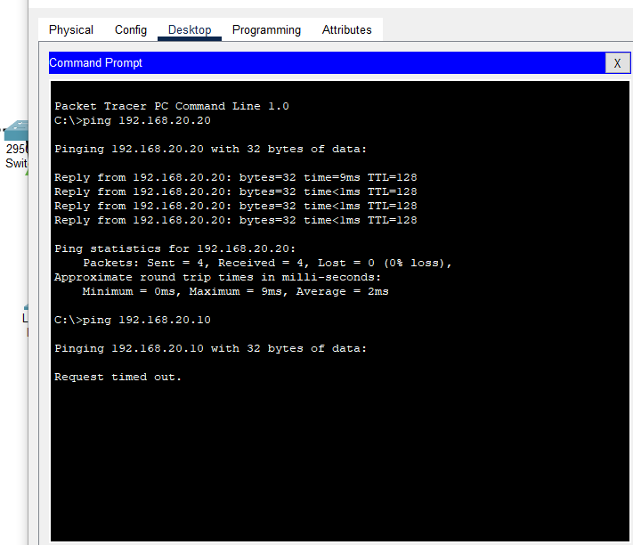

Discussion And Conclusion

In this lab we visualized the ospf routing protocol and VLAN network. We simulated the message passing and also the ip addresses were analysed.